Make your own QR Codes

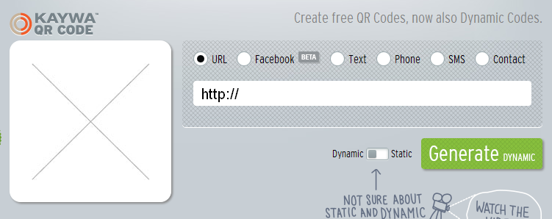
Resources: http://list.ly/3FV
Today’s Meet Backchannel: http://todaysmeet.com/qrcodesK-2
- Go to http://qrcode.kaywa.com/
- Choose URL or TEXT
- Click GENERATE
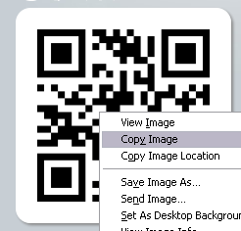
- Sometimes you may need to log in. Use your GOOGLE account to sign up
- Right click over the QR code and choose copy or CTRL-C
- Open up a Word document
- Hit enter to give yourself header space
- Choose Insert-Table and decide on a size
- Enter the problem number and hit enter
- Right click and choose paste or CTRL-V

Make your own QR Codes

Resources: http://list.ly/3FV
Today’s Meet Backchannel: http://todaysmeet.com/qrcodesK-2
- Go to http://qrcode.kaywa.com/
- Choose URL or TEXT
- Click GENERATE
- Sometimes you may need to log in. Use your GOOGLE account to sign up
- Right click over the QR code and choose copy or CTRL-C
- Open up a Word document
- Hit enter to give yourself header space
- Choose Insert-Table and decide on a size
- Enter the problem number and hit enter
- Right click and choose paste or CTRL-V

